SHELLMAN BLUFF 5TH ANNUAL
CHRISTMAS GOLF CART PARADE AND
LIGHTING OF THE TREE
December 7, 2019 at 6:00 PM
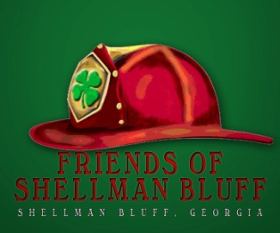

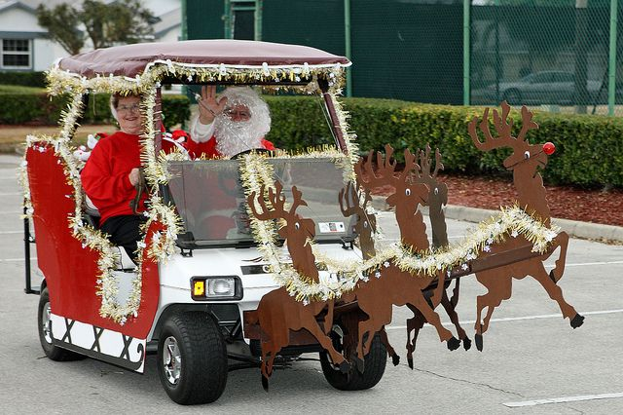

The lighting of the tree will be at The Friends of Shellman Bluff Park at 6:00 pm followed by singing Christmas Carols led by the Shellman Bluff Baptist Church Choir. Line up for the Parade will be immediately after the lighting of the tree. Minimum Entry Fee Donation - $25.00. All proceeds will go to the Friends of Shellman Bluff Park Infrastructure. Additional donations accepted for non-participation. Make checks out to Friends of Shellman Bluff and mail to P. O. Box 354 Townsend Georgia, 31331. Gift Certificates will be awarded for 1st, 2nd, and 3rd place best decorated Golf Cart. For additional information and entry forms go to Friends of Shellman Bluff web site at friendsofshellmanbluff.org , FOSB Facebook or call Gary Smith at 912 224 2445. The parade will begin and end at the Friends of Shellman Bluff Park.

